**Images In CSS**

By default, the images are the inline that means the element are set in a single line one by one because of inline the image have small spaces around the border to remove that we have to use the display elements to block



Display Inline



Display block

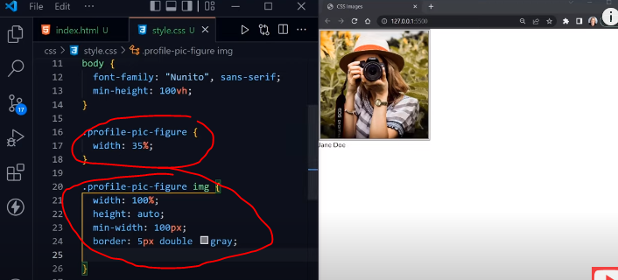

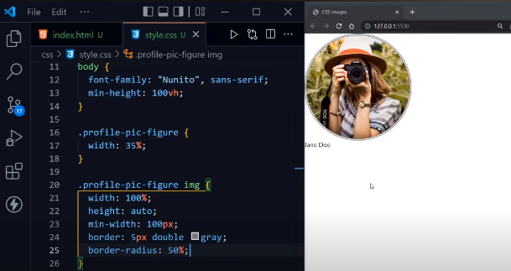

Background elements:

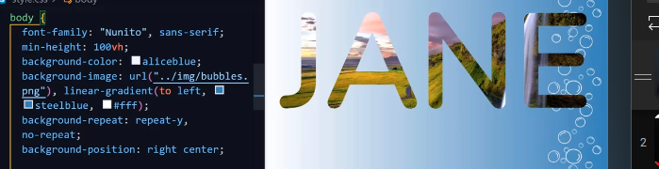

Background shorthand:

